|  |
| --- |
| The SAS System |

The GLM Procedure

| **Class Level Information** | | |
| --- | --- | --- |
| **Class** | **Levels** | **Values** |
| **SITE** | 2 | A B |
| **ZONE** | 4 | LZ MZ SZ(+TR) SZ(-TR) |

|  |  |
| --- | --- |
| **Number of Observations Read** | 40 |
| **Number of Observations Used** | 40 |

|  |
| --- |
| The SAS System |

The GLM Procedure

Dependent Variable: SQLIM100 SQLIM100

| **Source** | **DF** | **Sum of Squares** | **Mean Square** | **F Value** | **Pr > F** |
| --- | --- | --- | --- | --- | --- |
| **Model** | 7 | 77.4022795 | 11.0574685 | 3.20 | 0.0111 |
| **Error** | 32 | 110.6721904 | 3.4585060 |  |  |
| **Corrected Total** | 39 | 188.0744699 |  |  |  |

| **R-Square** | **Coeff Var** | **Root MSE** | **SQLIM100 Mean** |
| --- | --- | --- | --- |
| 0.411551 | 74.10515 | 1.859706 | 2.509550 |

| **Source** | **DF** | **Type III SS** | **Mean Square** | **F Value** | **Pr > F** |
| --- | --- | --- | --- | --- | --- |
| **SITE** | 1 | 6.37123240 | 6.37123240 | 1.84 | 0.1842 |
| **ZONE** | 3 | 39.24643370 | 13.08214457 | 3.78 | 0.0198 |
| **SITE*ZONE** | 3 | 31.78461340 | 10.59487113 | 3.06 | 0.0420 |

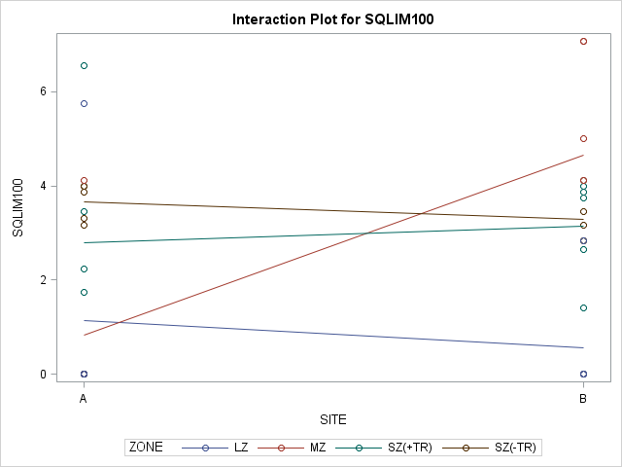

|  |
| --- |
| The SAS System |

The GLM Procedure

| **Source** | **Type III Expected Mean Square** |
| --- | --- |
| **SITE** | Var(Error) + 5 Var(SITE*ZONE) + 20 Var(SITE) |
| **ZONE** | Var(Error) + 5 Var(SITE*ZONE) + Q(ZONE) |
| **SITE*ZONE** | Var(Error) + 5 Var(SITE*ZONE) |

|  |
| --- |
| The SAS System |

The GLM Procedure

Tests of Hypotheses for Mixed Model Analysis of Variance

Dependent Variable: SQLIM100 SQLIM100

| **Source** | **DF** | **Type III SS** | **Mean Square** | **F Value** | **Pr > F** |
| --- | --- | --- | --- | --- | --- |
| **SITE** | 1 | 6.371232 | 6.371232 | 0.60 | 0.4946 |
| **ZONE** | 3 | 39.246434 | 13.082145 | 1.23 | 0.4332 |
| **Error: MS(SITE*ZONE)** | 3 | 31.784613 | 10.594871 |  |  |

| **Source** | **DF** | **Type III SS** | **Mean Square** | **F Value** | **Pr > F** |
| --- | --- | --- | --- | --- | --- |
| **SITE*ZONE** | 3 | 31.784613 | 10.594871 | 3.06 | 0.0420 |
| **Error: MS(Error)** | 32 | 110.672190 | 3.458506 |  |  |

|  |
| --- |
| The SAS System |

Least Squares Means

Adjustment for Multiple Comparisons: Tukey

Standard Errors and Probabilities Calculated Using the Type III MS for SITE*ZONE as an Error Term

| **ZONE** | **SQLIM100 LSMEAN** | **LSMEAN Number** |
| --- | --- | --- |
| **LZ** | 0.85730000 | 1 |
| **MZ** | 2.73880000 | 2 |
| **SZ(+TR)** | 2.96640000 | 3 |
| **SZ(-TR)** | 3.47570000 | 4 |

| **Least Squares Means for effect ZONE Pr > |t| for H0: LSMean(i)=LSMean(j) Dependent Variable: SQLIM100** | | | | |
| --- | --- | --- | --- | --- |
| **i/j** | **1** | **2** | **3** | **4** |
| **1** |  | 0.6235 | 0.5535 | 0.4175 |
| **2** | 0.6235 |  | 0.9983 | 0.9523 |
| **3** | 0.5535 | 0.9983 |  | 0.9827 |
| **4** | 0.4175 | 0.9523 | 0.9827 |  |

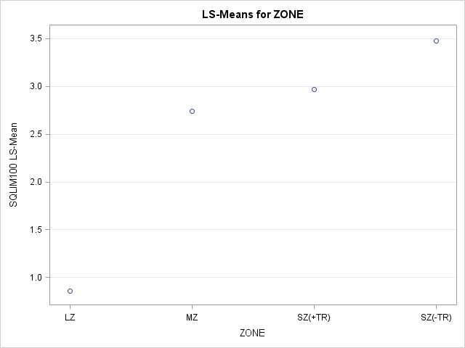

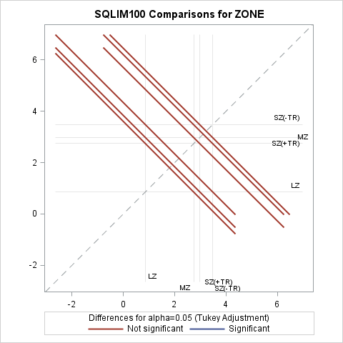

|  |
| --- |
| The SAS System |

Dependent Variable: SQLIM100 SQLIM100

| **Tests of Hypotheses Using the Type III MS for SITE*ZONE as an Error Term** | | | | | |
| --- | --- | --- | --- | --- | --- |
| **Source** | **DF** | **Type III SS** | **Mean Square** | **F Value** | **Pr > F** |
| **ZONE** | 3 | 39.24643370 | 13.08214457 | 1.23 | 0.4332 |

|  |
| --- |
| The SAS System |

The Mixed Procedure

| **Model Information** | |
| --- | --- |
| **Data Set** | WORK.LIMPETS |
| **Dependent Variable** | SQLIM100 |
| **Covariance Structure** | Variance Components |
| **Estimation Method** | REML |
| **Residual Variance Method** | Profile |
| **Fixed Effects SE Method** | Model-Based |
| **Degrees of Freedom Method** | Containment |

| **Class Level Information** | | |
| --- | --- | --- |
| **Class** | **Levels** | **Values** |
| **SITE** | 2 | A B |
| **ZONE** | 4 | LZ MZ SZ(+TR) SZ(-TR) |

| **Dimensions** | |
| --- | --- |
| **Covariance Parameters** | 3 |
| **Columns in X** | 5 |
| **Columns in Z** | 10 |
| **Subjects** | 1 |
| **Max Obs per Subject** | 40 |

| **Number of Observations** | |
| --- | --- |
| **Number of Observations Read** | 40 |
| **Number of Observations Used** | 40 |
| **Number of Observations Not Used** | 0 |

| **Iteration History** | | | |
| --- | --- | --- | --- |
| **Iteration** | **Evaluations** | **-2 Res Log Like** | **Criterion** |
| **0** | 1 | 162.46772770 |  |
| **1** | 3 | 160.10345382 | 0.00002528 |
| **2** | 1 | 160.10222999 | 0.00000006 |
| **3** | 1 | 160.10222729 | 0.00000000 |

|  |
| --- |
| Convergence criteria met. |

| **Covariance Parameter Estimates** | |
| --- | --- |
| **Cov Parm** | **Estimate** |
| **SITE** | 0 |
| **SITE*ZONE** | 1.2161 |
| **Residual** | 3.4585 |

| **Fit Statistics** | |
| --- | --- |
| **-2 Res Log Likelihood** | 160.1 |
| **AIC (Smaller is Better)** | 164.1 |
| **AICC (Smaller is Better)** | 164.5 |
| **BIC (Smaller is Better)** | 161.5 |

| **Type 3 Tests of Fixed Effects** | | | | |
| --- | --- | --- | --- | --- |
| **Effect** | **Num DF** | **Den DF** | **F Value** | **Pr > F** |
| **ZONE** | 3 | 3 | 1.37 | 0.4007 |

| **Least Squares Means** | | | | | | |
| --- | --- | --- | --- | --- | --- | --- |
| **Effect** | **ZONE** | **Estimate** | **Standard Error** | **DF** | **t Value** | **Pr > |t|** |
| **ZONE** | **LZ** | 0.8573 | 0.9767 | 3 | 0.88 | 0.4447 |
| **ZONE** | **MZ** | 2.7388 | 0.9767 | 3 | 2.80 | 0.0676 |
| **ZONE** | **SZ(+TR)** | 2.9664 | 0.9767 | 3 | 3.04 | 0.0560 |
| **ZONE** | **SZ(-TR)** | 3.4757 | 0.9767 | 3 | 3.56 | 0.0379 |

| **Differences of Least Squares Means** | | | | | | | | | |
| --- | --- | --- | --- | --- | --- | --- | --- | --- | --- |
| **Effect** | **ZONE** | **ZONE** | **Estimate** | **Standard Error** | **DF** | **t Value** | **Pr > |t|** | **Adjustment** | **Adj P** |
| **ZONE** | **LZ** | **MZ** | -1.8815 | 1.3812 | 3 | -1.36 | 0.2664 | Tukey | 0.5917 |
| **ZONE** | **LZ** | **SZ(+TR)** | -2.1091 | 1.3812 | 3 | -1.53 | 0.2242 | Tukey | 0.5204 |
| **ZONE** | **LZ** | **SZ(-TR)** | -2.6184 | 1.3812 | 3 | -1.90 | 0.1543 | Tukey | 0.3855 |
| **ZONE** | **MZ** | **SZ(+TR)** | -0.2276 | 1.3812 | 3 | -0.16 | 0.8796 | Tukey | 0.9981 |
| **ZONE** | **MZ** | **SZ(-TR)** | -0.7369 | 1.3812 | 3 | -0.53 | 0.6307 | Tukey | 0.9452 |
| **ZONE** | **SZ(+TR)** | **SZ(-TR)** | -0.5093 | 1.3812 | 3 | -0.37 | 0.7368 | Tukey | 0.9800 |

|  |
| --- |
| The SAS System |

The GLM Procedure

| **Class Level Information** | | |
| --- | --- | --- |
| **Class** | **Levels** | **Values** |
| **SITE** | 2 | A B |
| **ZONE** | 4 | LZ MZ SZ(+TR) SZ(-TR) |

|  |  |
| --- | --- |
| **Number of Observations Read** | 33 |
| **Number of Observations Used** | 33 |

|  |
| --- |
| The SAS System |

The GLM Procedure

Dependent Variable: SQLIM100 SQLIM100

| **Source** | **DF** | **Sum of Squares** | **Mean Square** | **F Value** | **Pr > F** |
| --- | --- | --- | --- | --- | --- |
| **Model** | 7 | 40.0667341 | 5.7238192 | 1.51 | 0.2084 |
| **Error** | 25 | 94.5715074 | 3.7828603 |  |  |
| **Corrected Total** | 32 | 134.6382415 |  |  |  |

| **R-Square** | **Coeff Var** | **Root MSE** | **SQLIM100 Mean** |
| --- | --- | --- | --- |
| 0.297588 | 63.93935 | 1.944958 | 3.041879 |

| **Source** | **DF** | **Type III SS** | **Mean Square** | **F Value** | **Pr > F** |
| --- | --- | --- | --- | --- | --- |
| **SITE** | 1 | 2.94087003 | 2.94087003 | 0.78 | 0.3863 |
| **ZONE** | 3 | 16.36372579 | 5.45457526 | 1.44 | 0.2543 |
| **SITE*ZONE** | 3 | 18.45261828 | 6.15087276 | 1.63 | 0.2085 |

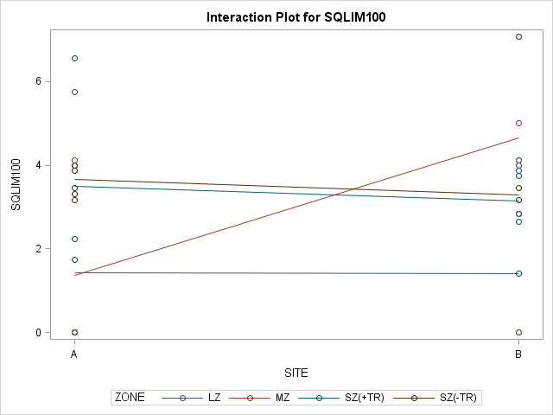

|  |
| --- |
| The SAS System |

The GLM Procedure

| **Source** | **Type III Expected Mean Square** |
| --- | --- |
| **SITE** | Var(Error) + 3.75 Var(SITE*ZONE) + 15 Var(SITE) |
| **ZONE** | Var(Error) + 3.9015 Var(SITE*ZONE) + Q(ZONE) |
| **SITE*ZONE** | Var(Error) + 3.9015 Var(SITE*ZONE) |

|  |
| --- |
| The SAS System |

The GLM Procedure

Tests of Hypotheses for Mixed Model Analysis of Variance

Dependent Variable: SQLIM100 SQLIM100

| **Source** | **DF** | **Type III SS** | **Mean Square** | **F Value** | **Pr > F** |
| --- | --- | --- | --- | --- | --- |
| **SITE** | 1 | 2.940870 | 2.940870 | 0.49 | 0.5339 |
| **Error** | 3.1507 | 19.089983 | 6.058898 |  |  |
| **Error: 0.9612*MS(SITE*ZONE) + 0.0388*MS(Error)** | | | | | |

| **Source** | **DF** | **Type III SS** | **Mean Square** | **F Value** | **Pr > F** |
| --- | --- | --- | --- | --- | --- |
| **ZONE** | 3 | 16.363726 | 5.454575 | 0.89 | 0.5382 |
| **Error: MS(SITE*ZONE)** | 3 | 18.452618 | 6.150873 |  |  |

| **Source** | **DF** | **Type III SS** | **Mean Square** | **F Value** | **Pr > F** |
| --- | --- | --- | --- | --- | --- |
| **SITE*ZONE** | 3 | 18.452618 | 6.150873 | 1.63 | 0.2085 |
| **Error: MS(Error)** | 25 | 94.571507 | 3.782860 |  |  |

|  |
| --- |
| The SAS System |

Least Squares Means

Adjustment for Multiple Comparisons: Tukey-Kramer

Standard Errors and Probabilities Calculated Using the Type III MS for SITE*ZONE as an Error Term

| **ZONE** | **SQLIM100 LSMEAN** | **LSMEAN Number** |
| --- | --- | --- |
| **LZ** | 1.42512500 | 1 |
| **MZ** | 3.01366667 | 2 |
| **SZ(+TR)** | 3.31612500 | 3 |
| **SZ(-TR)** | 3.47570000 | 4 |

| **Least Squares Means for effect ZONE Pr > |t| for H0: LSMean(i)=LSMean(j) Dependent Variable: SQLIM100** | | | | |
| --- | --- | --- | --- | --- |
| **i/j** | **1** | **2** | **3** | **4** |
| **1** |  | 0.6997 | 0.5784 | 0.5142 |
| **2** | 0.6997 |  | 0.9937 | 0.9773 |
| **3** | 0.5784 | 0.9937 |  | 0.9988 |
| **4** | 0.5142 | 0.9773 | 0.9988 |  |

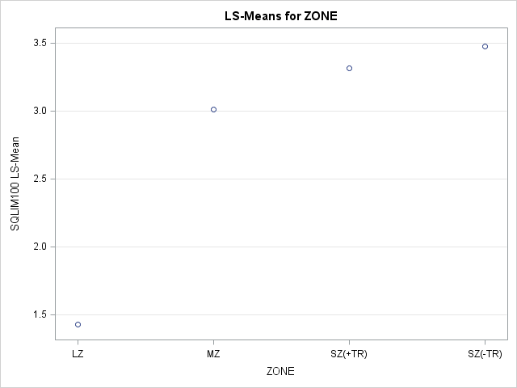

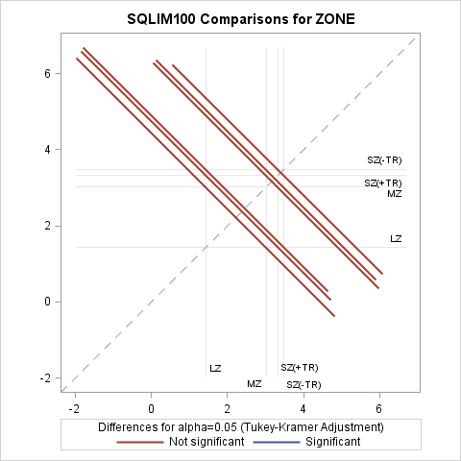

|  |
| --- |
| The SAS System |

Dependent Variable: SQLIM100 SQLIM100

| **Tests of Hypotheses Using the Type III MS for SITE*ZONE as an Error Term** | | | | | |
| --- | --- | --- | --- | --- | --- |
| **Source** | **DF** | **Type III SS** | **Mean Square** | **F Value** | **Pr > F** |
| **ZONE** | 3 | 16.36372579 | 5.45457526 | 0.89 | 0.5382 |

|  |
| --- |
| The SAS System |

The Mixed Procedure

| **Model Information** | |
| --- | --- |
| **Data Set** | WORK.UNBAL |
| **Dependent Variable** | SQLIM100 |
| **Covariance Structure** | Variance Components |
| **Estimation Method** | REML |
| **Residual Variance Method** | Profile |
| **Fixed Effects SE Method** | Model-Based |
| **Degrees of Freedom Method** | Containment |

| **Class Level Information** | | |
| --- | --- | --- |
| **Class** | **Levels** | **Values** |
| **SITE** | 2 | A B |
| **ZONE** | 4 | LZ MZ SZ(+TR) SZ(-TR) |

| **Dimensions** | |
| --- | --- |
| **Covariance Parameters** | 3 |
| **Columns in X** | 5 |
| **Columns in Z** | 10 |
| **Subjects** | 1 |
| **Max Obs per Subject** | 33 |

| **Number of Observations** | |
| --- | --- |
| **Number of Observations Read** | 33 |
| **Number of Observations Used** | 33 |
| **Number of Observations Not Used** | 0 |

| **Iteration History** | | | |
| --- | --- | --- | --- |
| **Iteration** | **Evaluations** | **-2 Res Log Like** | **Criterion** |
| **0** | 1 | 130.72120654 |  |
| **1** | 3 | 130.57630954 | 0.00003110 |
| **2** | 1 | 130.57507093 | 0.00000007 |
| **3** | 1 | 130.57506817 | 0.00000000 |

|  |
| --- |
| Convergence criteria met. |

| **Covariance Parameter Estimates** | |
| --- | --- |
| **Cov Parm** | **Estimate** |
| **SITE** | 0 |
| **SITE*ZONE** | 0.3365 |
| **Residual** | 3.7991 |

| **Fit Statistics** | |
| --- | --- |
| **-2 Res Log Likelihood** | 130.6 |
| **AIC (Smaller is Better)** | 134.6 |
| **AICC (Smaller is Better)** | 135.0 |
| **BIC (Smaller is Better)** | 132.0 |

| **Type 3 Tests of Fixed Effects** | | | | |
| --- | --- | --- | --- | --- |
| **Effect** | **Num DF** | **Den DF** | **F Value** | **Pr > F** |
| **ZONE** | 3 | 3 | 1.25 | 0.4294 |

| **Least Squares Means** | | | | | | |
| --- | --- | --- | --- | --- | --- | --- |
| **Effect** | **ZONE** | **Estimate** | **Standard Error** | **DF** | **t Value** | **Pr > |t|** |
| **ZONE** | **LZ** | 1.4281 | 0.9036 | 3 | 1.58 | 0.2121 |
| **ZONE** | **MZ** | 3.3213 | 0.8069 | 3 | 4.12 | 0.0260 |
| **ZONE** | **SZ(+TR)** | 3.3017 | 0.7693 | 3 | 4.29 | 0.0233 |
| **ZONE** | **SZ(-TR)** | 3.4757 | 0.7404 | 3 | 4.69 | 0.0183 |

| **Differences of Least Squares Means** | | | | | | | | | |
| --- | --- | --- | --- | --- | --- | --- | --- | --- | --- |
| **Effect** | **ZONE** | **ZONE** | **Estimate** | **Standard Error** | **DF** | **t Value** | **Pr > |t|** | **Adjustment** | **Adj P** |
| **ZONE** | **LZ** | **MZ** | -1.8932 | 1.2114 | 3 | -1.56 | 0.2160 | Tukey-Kramer | 0.5058 |
| **ZONE** | **LZ** | **SZ(+TR)** | -1.8736 | 1.1868 | 3 | -1.58 | 0.2125 | Tukey-Kramer | 0.4994 |
| **ZONE** | **LZ** | **SZ(-TR)** | -2.0476 | 1.1682 | 3 | -1.75 | 0.1779 | Tukey-Kramer | 0.4335 |
| **ZONE** | **MZ** | **SZ(+TR)** | 0.01963 | 1.1148 | 3 | 0.02 | 0.9871 | Tukey-Kramer | 1.0000 |
| **ZONE** | **MZ** | **SZ(-TR)** | -0.1544 | 1.0951 | 3 | -0.14 | 0.8968 | Tukey-Kramer | 0.9988 |
| **ZONE** | **SZ(+TR)** | **SZ(-TR)** | -0.1740 | 1.0677 | 3 | -0.16 | 0.8809 | Tukey-Kramer | 0.9981 |